ABC’s Inventory Management System

Test Script

Table of Contents

APT001- Search The Known Transfer Then Accept This Transfer 3

Data Set 1 3

Data Set 2 6

Data Set 3 9

APT002- Search Unknown Transfer Then Accept This Transfer 12

Data Set 1 12

Data Set 2 14

Data Set 3 15

APT003 - Accept The Existed Products In Current Location 17

Data Set 1 17

Data Set 2 20

Data Set 3 22

APT004- Accept The New Products In Current Location 25

Data Set 1 25

Data Set 2 28

Data Set 3 31

# APT001- Search The Known Transfer Then Accept This Transfer

|  |  |  |  |  |  |
| --- | --- | --- | --- | --- | --- |
| **Test Name** | | Search The Known Transfer Then Accept This Transfer (Test Case APT001) | | | |
| **Use Case Tested** | | Accept Product | | | |
| **Test Description** | | This test tests if the system can accept products and its quantity by searching the existing sending transfer ID. | | | |
| **Pre-Conditions** | | Meta data must exist, product details like product item code, sending location ID and product quantity; transfer details like transfer date, transfer ID, description. | | | |
| **Post-Conditions** | | Accepted Products should be added to the current location, the status of transfer change to “Accepted”, the accepted transfer should be removed from the accept transfer table, the quantity of accepted products should be changed appropriately. | | | |
| **Notes** | | This test assumes that the user knows the transferID. | | | |
| **Result (Pass/Fail/Warning/ Incomplete)** | | Pass | | | |
|  | **Test Step** | | **Expected Test Results** | **P** | **F** |
| 1. | Select Accept Product Button from home page | | Display the Accept Product page |  |  |
| 2. | Input transfer ID in search field and click on the Search Button | | System display correct searched transfer |  |  |
| 3. | Click on the “View Product in this Transfer” button to check the sending products detail for accepting | | System displays a list of sending products and its quantity | P |  |
| 4. | Click on the “Accept” Button | | Sending Products are added to the current location, the status of transfer change to “Accepted”, the accepted transfer is removed from the accept transfer table, the quantity of accepted products are changed appropriately. | P |  |

## Data Set 1

|  |  |
| --- | --- |
| **Test Data Table** | |
| **transferID** | 47 |
| **Destination** | Oxford Store |

#### Result Screenshots

The screenshots of the result on each test step for each data set are given below:

**Step 1**

Open the Accept Product Page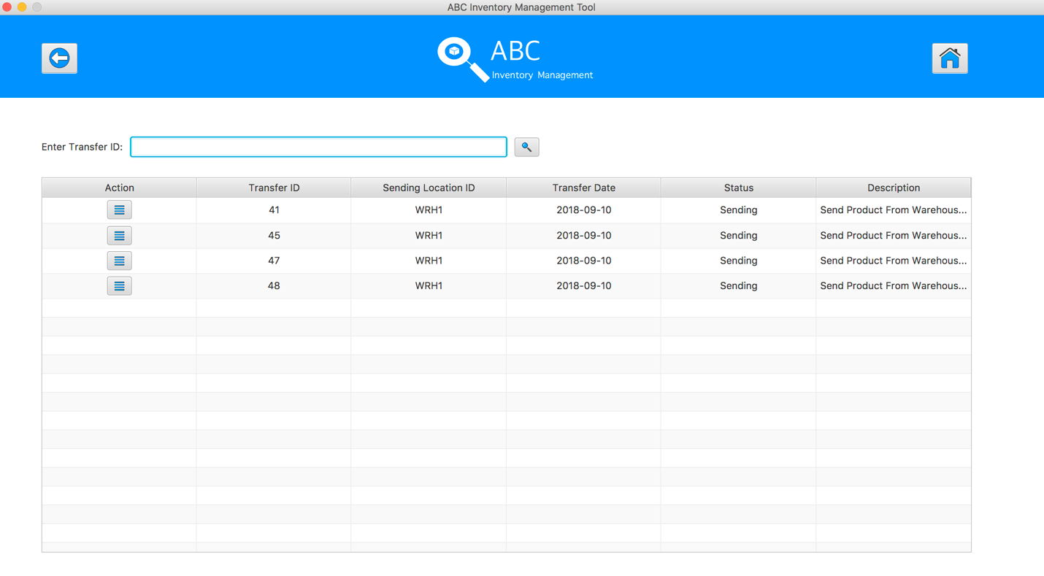

**Step 2**

Input transfer ID in search field and click on the Search Button

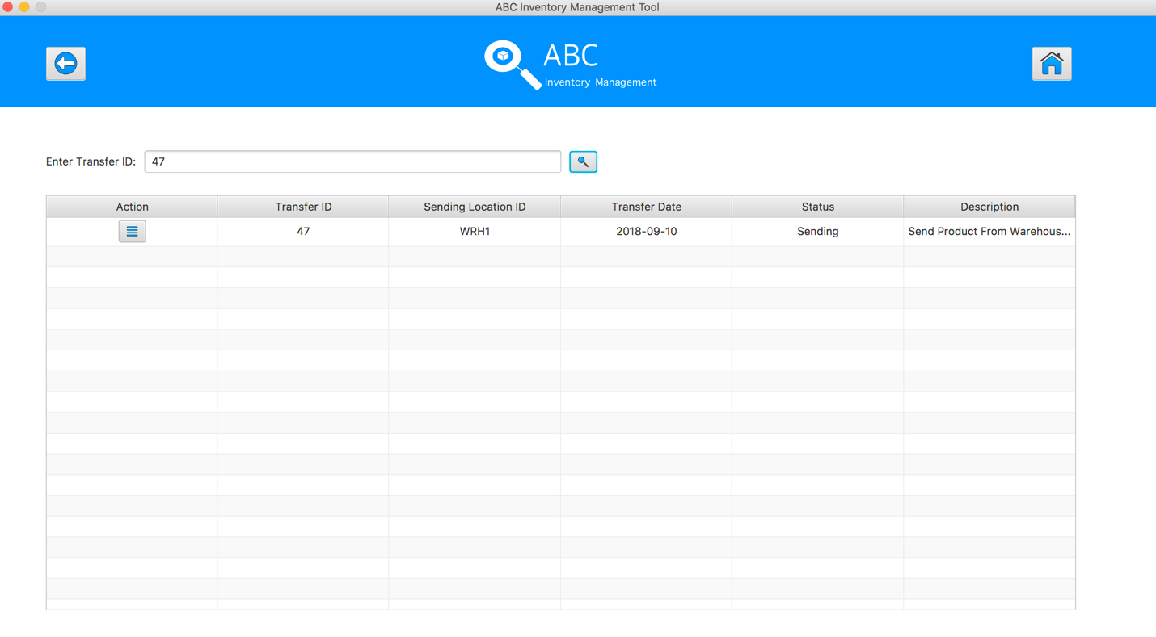

**Step 3**

Click on the “View Product in this Transfer” button, the system displays the sending products detail for accepting 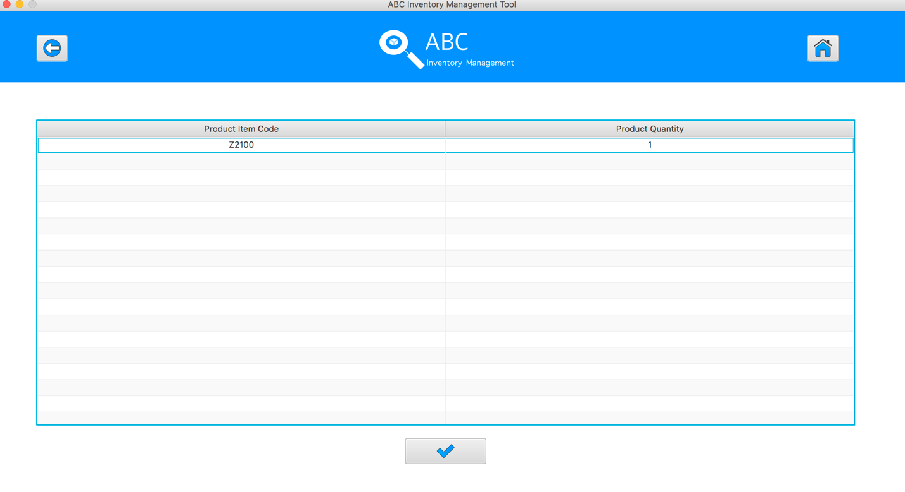

**Step 4**

Click on the “Accept” Button 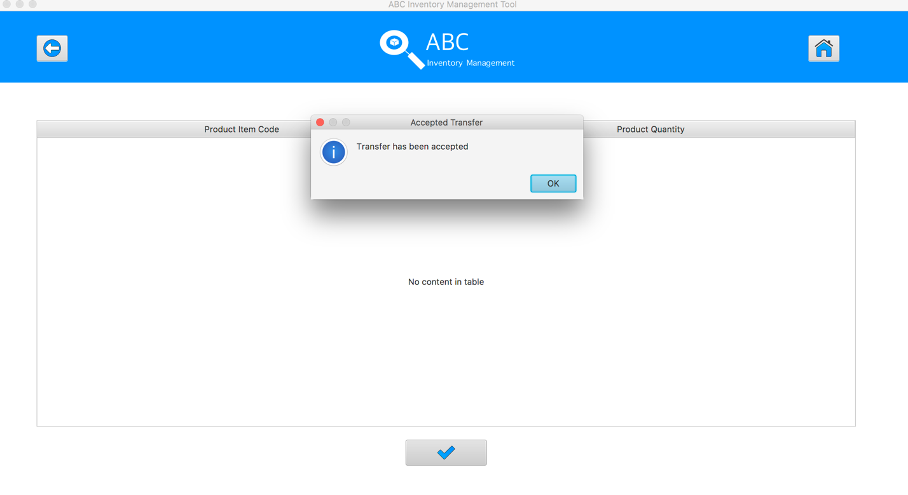

The quantity of accepted product will be changed appropriately.

|  |  |
| --- | --- |
| Before | After |
|  |  |

**APT001- Search The Known Transfer Then Accept This Transfer** **for Data Set 1:** **PASS**

## Data Set 2

|  |  |
| --- | --- |
| **Test Data Table** | |
| **transferID** | 44 |
| **Destination** | Epping Store |

#### Result Screenshots

The screenshots of the result on each test step for each data set are given below:

**Step 1**

Open the Accept Product Page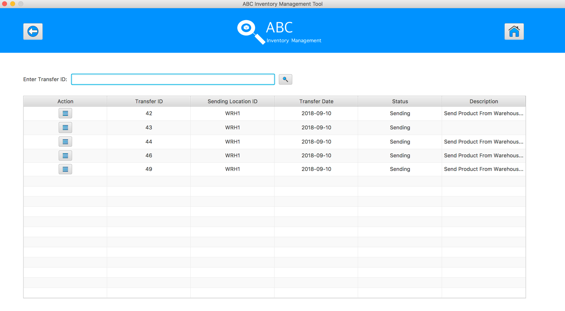

**Step 2**

Input transfer ID in search field and click on the Search Button

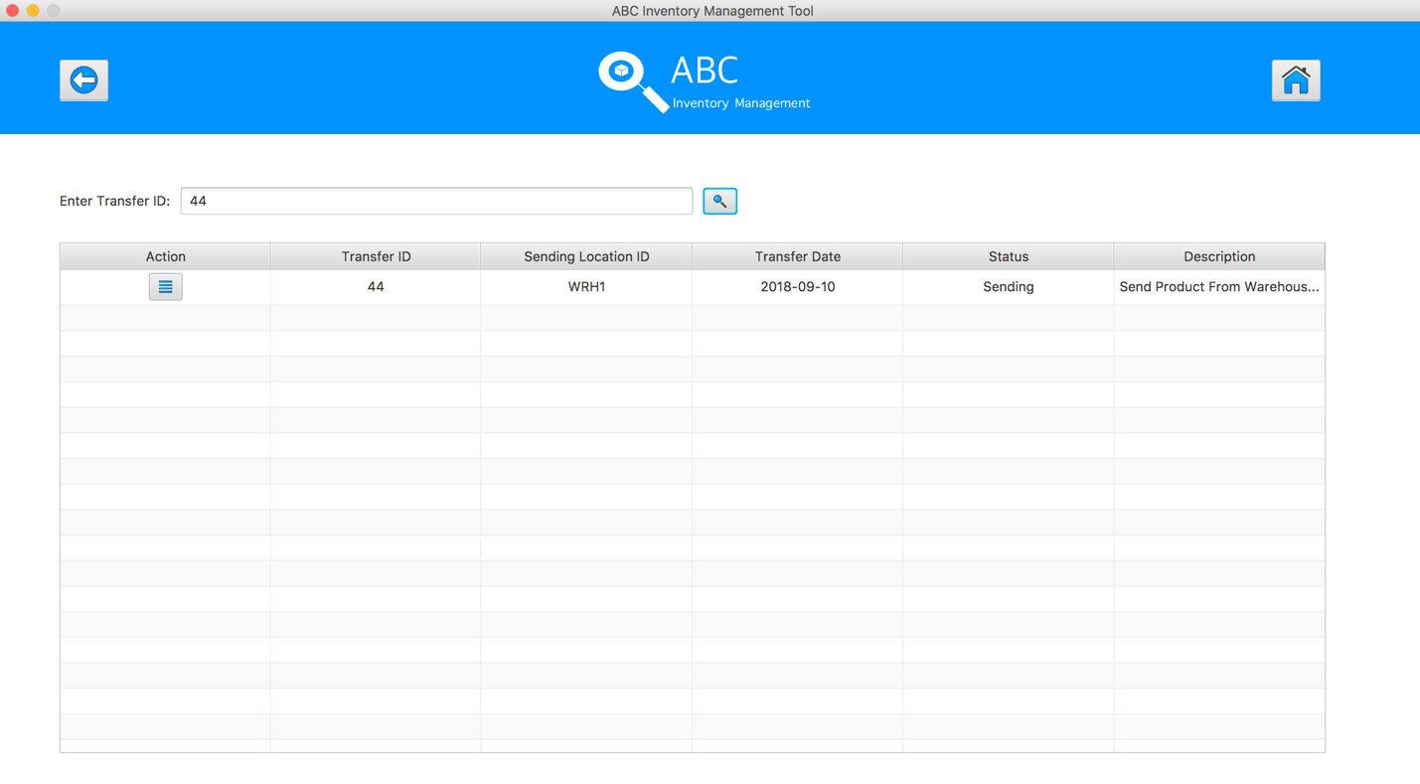

**Step 3**

Click on the “View Product in this Transfer” button, the system displays the sending products detail for accepting 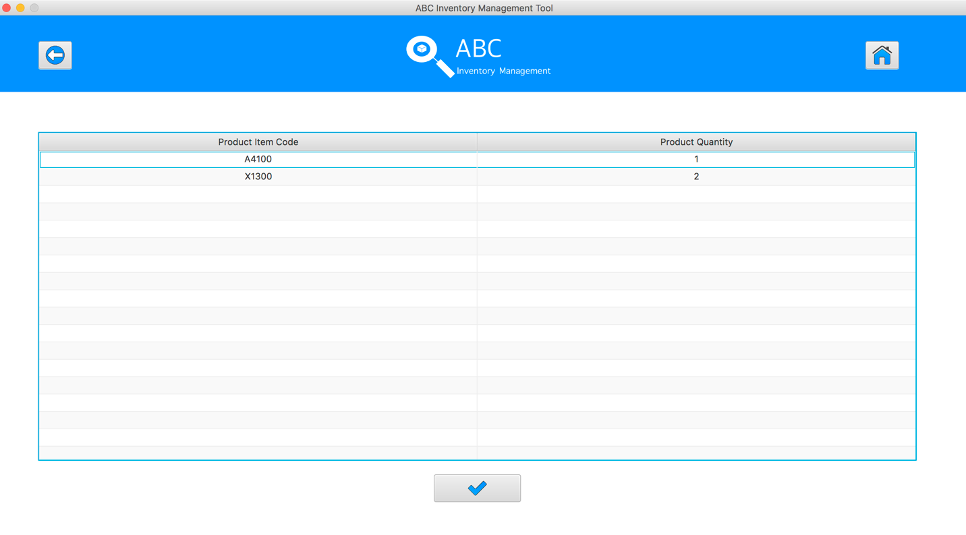

**Step 4**

Click on the “Accept” Button 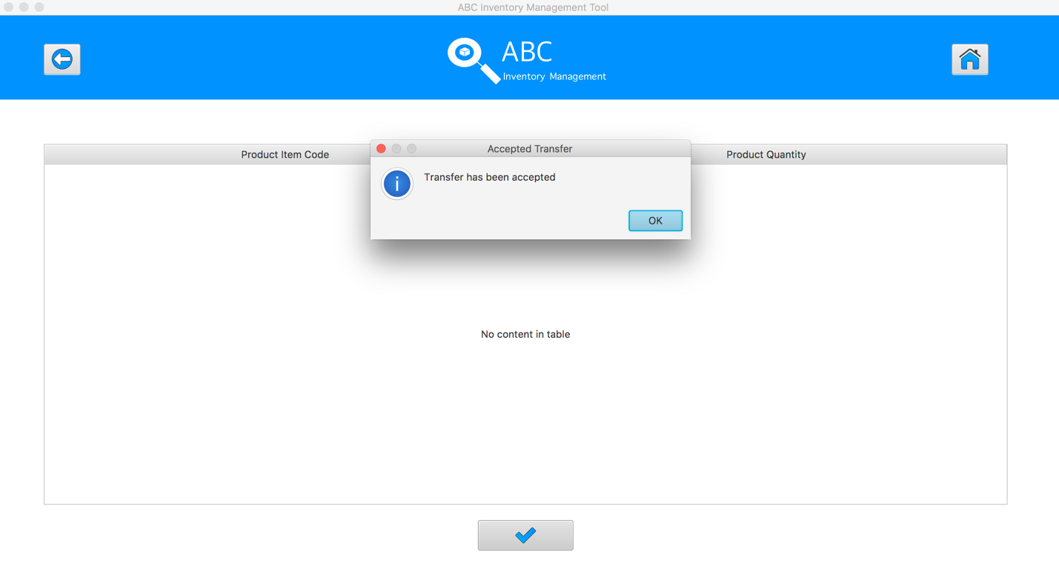

The quantity of accepted product will be changed appropriately.

|  |  |
| --- | --- |
| Before | After |
|  |  |

**APT001- Search The Known Transfer Then Accept This Transfer** **for Data Set 2:** **PASS**

## Data Set 3

|  |  |
| --- | --- |
| **Test Data Table** | |
| **transferID** | 50 |
| **Destination** | Warehouse |

#### Result Screenshots

The screenshots of the result on each test step for each data set are given below:

**Step 1**

Open the Accept Product Page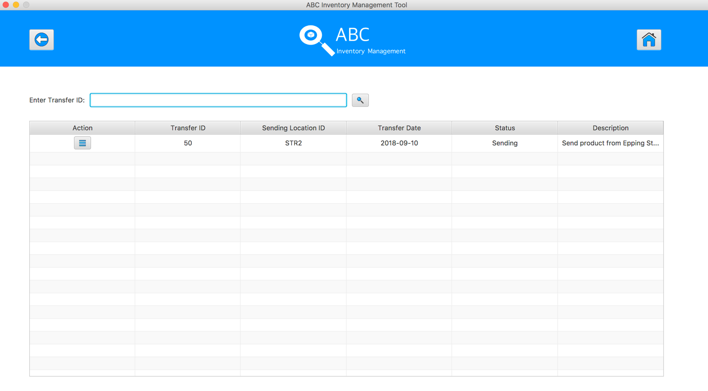

**Step 2**

Input transfer ID in search field and click on the Search Button

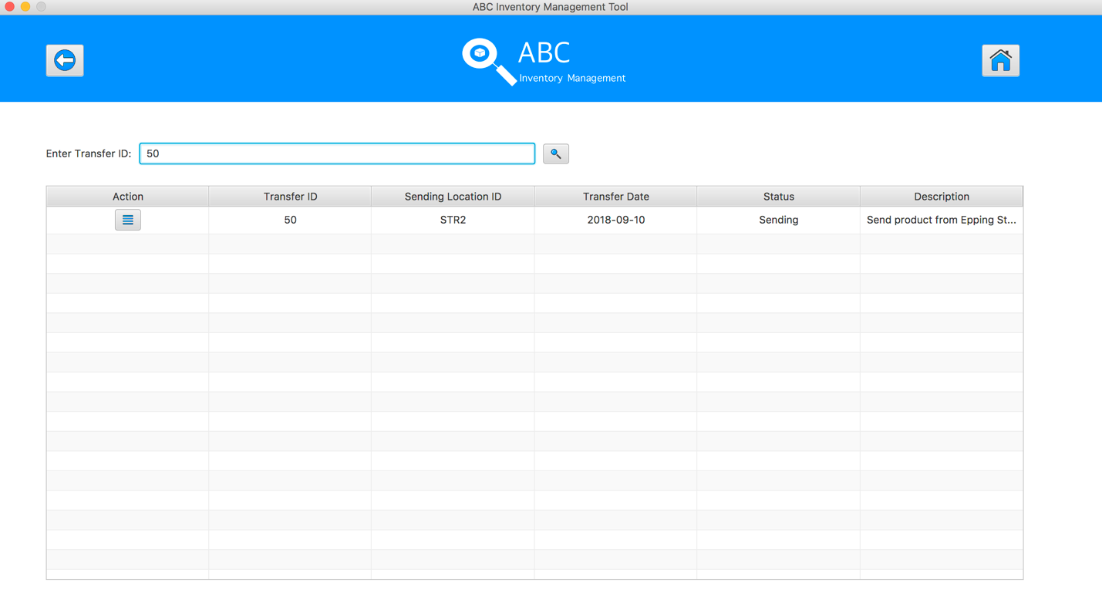

**Step 3**

Click on the “View Product in this Transfer” button, the system displays the sending products detail for accepting 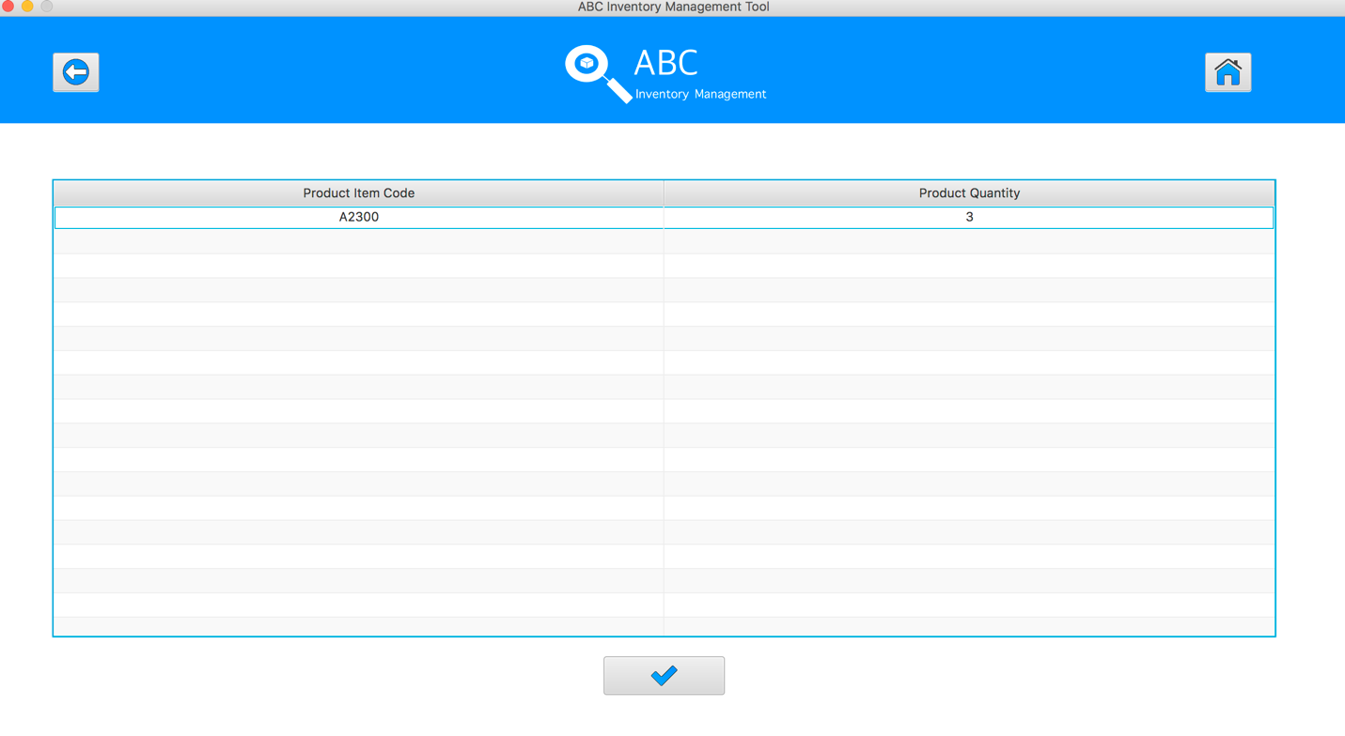

**Step 4**

Click on the “Accept” Button 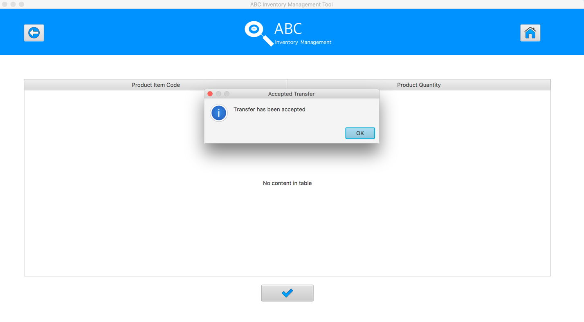

The quantity of accepted product will be changed appropriately.

|  |  |
| --- | --- |
| Before | After |
|  |  |

**APT001- Test Send Correct Quantity Of Product To The Destination** **for Data Set 3:** **PASS**

# APT002- Search Unknown Transfer Then Accept This Transfer

|  |  |  |  |  |  |
| --- | --- | --- | --- | --- | --- |
| **Test Name** | | Search Unknown Transfer Then Accept This Transfer (Test Case APT002) | | | |
| **Use Case Tested** | | Accept Product | | | |
| **Test Description** | | This test tests if the system can accept products and its quantity by searching the unknown sending transfer ID. | | | |
| **Pre-Conditions** | | Meta data must exist, product details like product item code, sending location ID and product quantity; transfer details like transfer date, transfer ID, description. | | | |
| **Post-Conditions** | | Appropriate alert message is displayed | | | |
| **Notes** | | This test assumes that the user knows the transferID. | | | |
| **Result (Pass/Fail/Warning/ Incomplete)** | | Pass | | | |
|  | **Test Step** | | **Expected Test Results** | **P** | **F** |
| 1. | Select Accept Product Button from home page | | Display the Accept Product page | P |  |
| 2. | Input incorrect transfer ID in search field and click on the Search Button | | System display an appropriate alert message | P |  |

## Data Set 1

|  |  |
| --- | --- |
| **Test Data Table** | |
| **transferID** | 40 |
| **Destination** | Oxford Store |

#### Result Screenshots

The screenshots of the result on each test step for each data set are given below:

**Step 1**

Open the Accept Product Page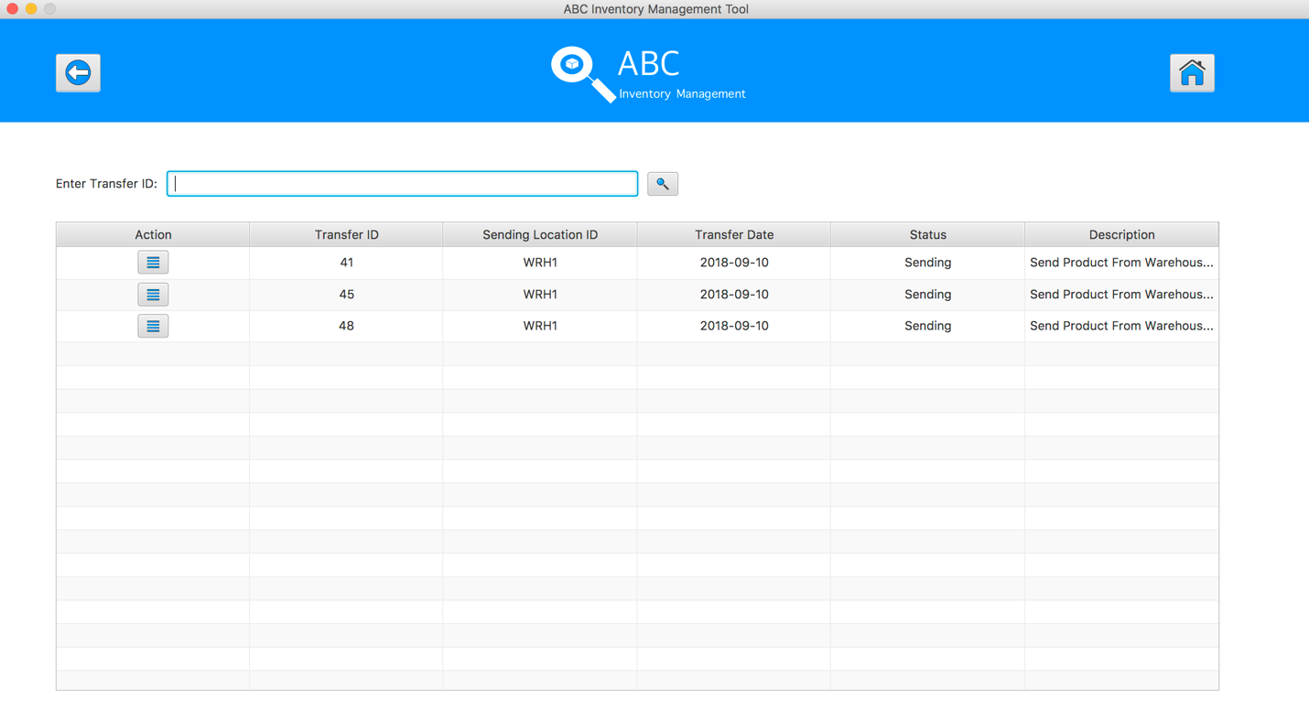

**Step 2**

Input incorrect transfer ID in search field and click on the Search Button. An alert message pops up to notify user entered wrong ID

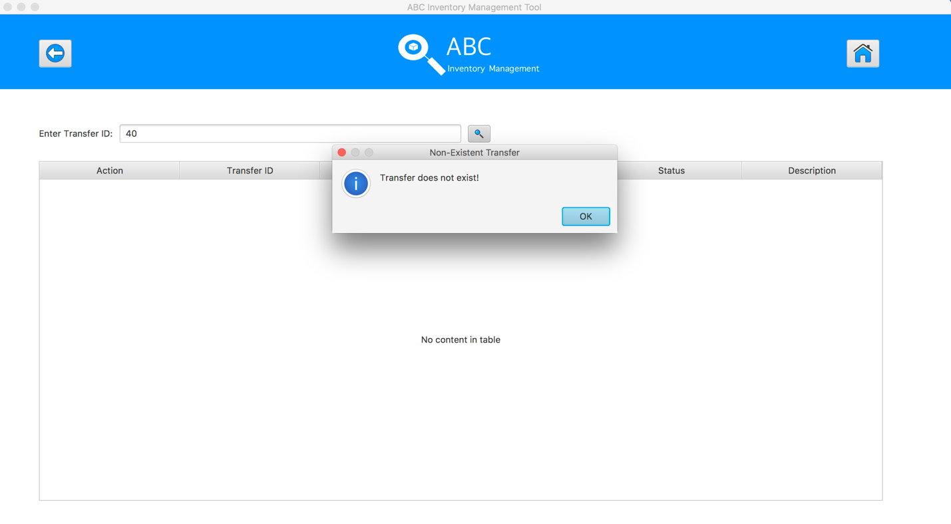

**APT002- Search Unknown Transfer Then Accept This Transfer for Data Set 1:** **PASS**

## Data Set 2

|  |  |
| --- | --- |
| **Test Data Table** | |
| **transferID** | ab |
| **Destination** | Oxford Store |

#### Result Screenshots

The screenshots of the result on each test step for each data set are given below:

**Step 1**

Open the Accept Product Page

**Step 2**

Input incorrect transfer ID in search field and click on the Search Button. An alert message pops up to notify user entered wrong ID

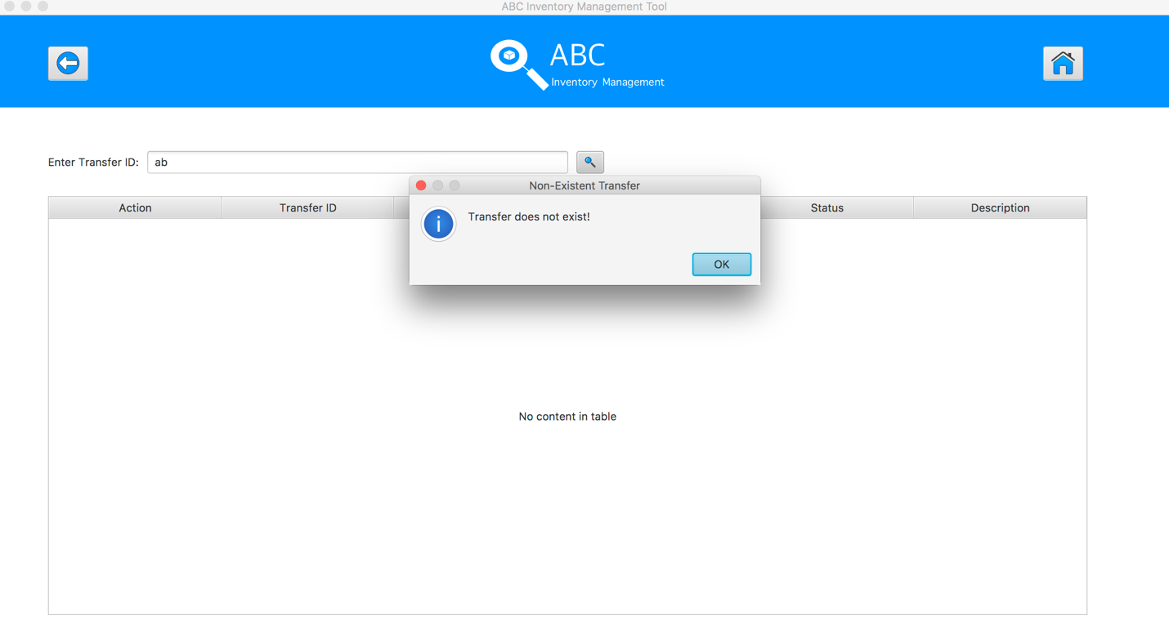

**APT002- Search Unknown Transfer Then Accept This Transfer for Data Set 2:** **PASS**

## Data Set 3

|  |  |
| --- | --- |
| **Test Data Table** | |
| **transferID** | -3 |
| **Destination** | Oxford Store |

#### Result Screenshots

The screenshots of the result on each test step for each data set are given below:

**Step 1**

Open the Accept Product Page

**Step 2**

Input incorrect transfer ID in search field and click on the Search Button. An alert message pops up to notify user entered wrong ID

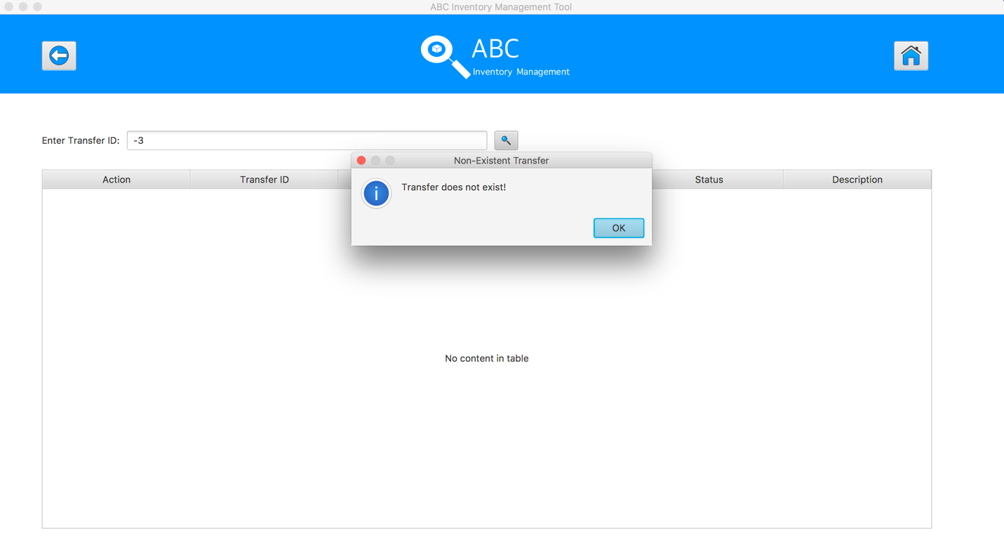

**APT002- Search Unknown Transfer Then Accept This Transfer for Data Set 3:** **PASS**

# APT003 - Accept The Existed Products In Current Location

|  |  |  |  |  |  |
| --- | --- | --- | --- | --- | --- |
| **Test Name** | | Accept The Existed Products In Current Location (Test Case APT003) | | | |
| **Use Case Tested** | | Accept Product | | | |
| **Test Description** | | This test tests if the system can accept transfer that sending the products what have been recorded its information in current destination. | | | |
| **Pre-Conditions** | | Meta data must exist, product details like product item code, sending location ID and product quantity; transfer details like transfer date, transfer ID, description. | | | |
| **Post-Conditions** | | Accepted Products should be added to the current location, the status of transfer change to “Accepted”, the accepted transfer should be removed from the accept transfer table, the quantity of accepted products should be changed appropriately. | | | |
| **Notes** | | This test assumes that the user knows the transferID. | | | |
| **Result (Pass/Fail/Warning/ Incomplete)** | | Pass | | | |
|  | **Test Step** | | **Expected Test Results** | **P** | **F** |
| 1. | Select Accept Product Button from home page | | Display the Accept Product page |  |  |
| 2. | Input transfer ID in search field and click on the Search Button | | System display correct searched transfer |  |  |
| 3. | Click on the “View Product in this Transfer” button to check the sending products detail for accepting | | System displays a list of sending products and its quantity | P |  |
| 4. | Click on the “Accept” Button | | Sending Product quantities are added to the current location, the status of transfer change to “Accepted”, the accepted transfer is removed from the accept transfer table, the quantity of accepted products are changed appropriately. | P |  |

## Data Set 1

|  |  |
| --- | --- |
| **Test Data Table** | |
| **transferID** | 47 |
| **Destination** | Oxford Store |

#### Result Screenshots

The screenshots of the result on each test step for each data set are given below:

**Step 1**

Open the Accept Product Page

**Step 2**

Input transfer ID in search field and click on the Search Button



**Step 3**

Click on the “View Product in this Transfer” button, the system displays the sending products detail for accepting 

**Step 4**

Click on the “Accept” Button 

The quantity of accepted product will be changed appropriately.

|  |  |
| --- | --- |
| Before | After |
|  |  |

**APT003- Test Accept The Existed Products In Current Location for Data Set 1:** **PASS**

## Data Set 2

|  |  |
| --- | --- |
| **Test Data Table** | |
| **transferID** | 52 |
| **Destination** | Epping Store |

#### Result Screenshots

The screenshots of the result on each test step for each data set are given below:

**Step 1**

Open the Accept Product Page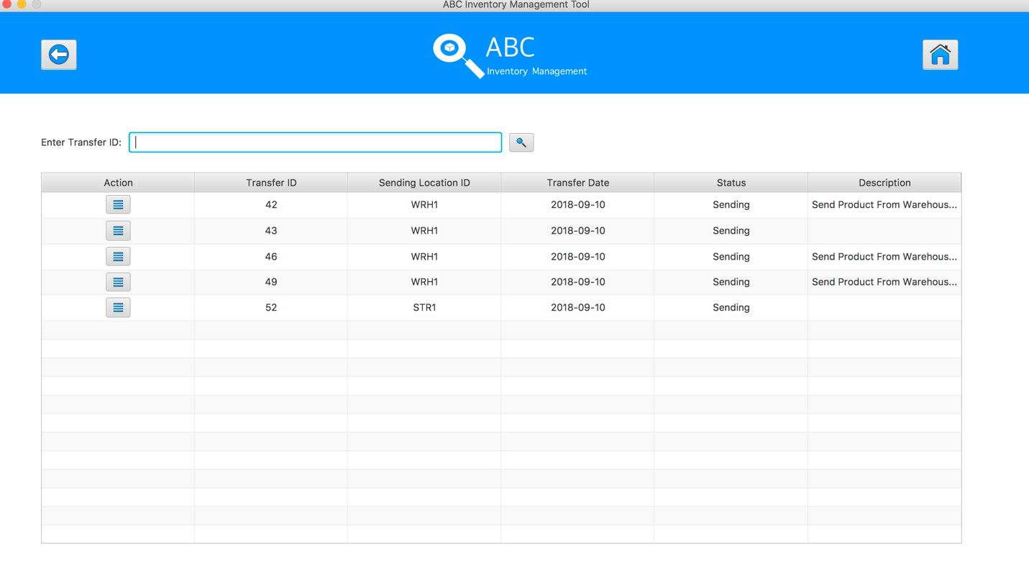

**Step 2**

Click on the “View Product in this Transfer” button of transfer ID = 52, the system displays the sending products detail for accepting 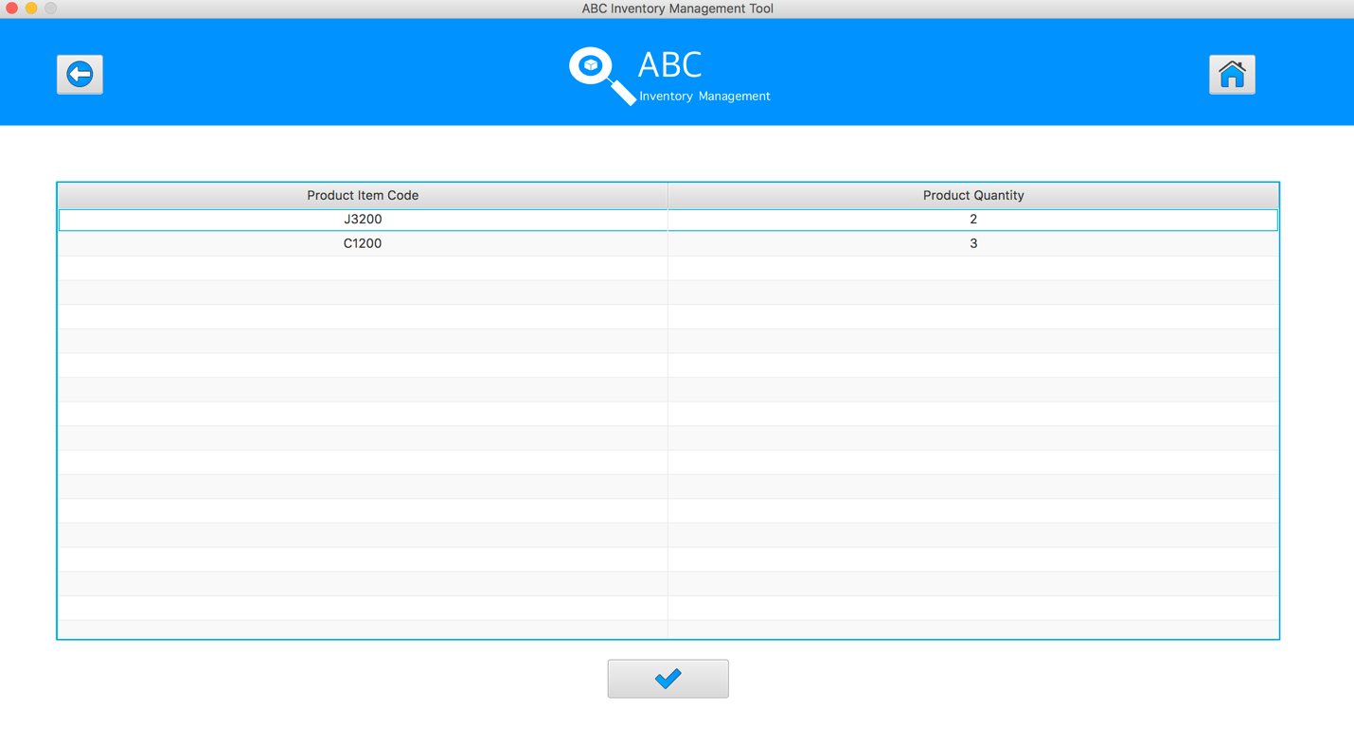

**Step 3**

Click on the “Accept” Button 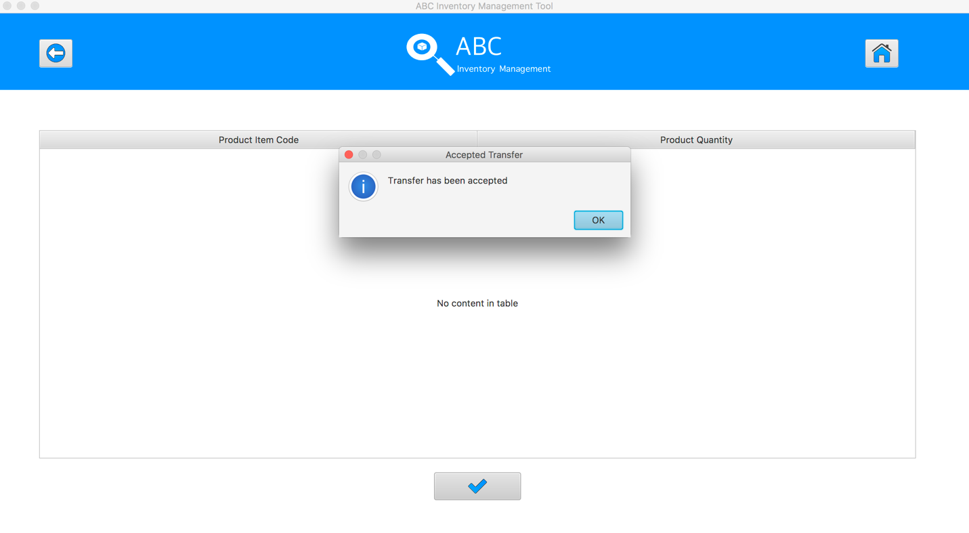

The quantity of accepted product will be changed appropriately.

|  |  |
| --- | --- |
| Before | After |
|  |  |

**APT003- Test Accept The Existed Products In Current Location for Data Set 2:** **PASS**

## Data Set 3

|  |  |
| --- | --- |
| **Test Data Table** | |
| **transferID** | 53 |
| **Destination** | Warehouse |

#### Result Screenshots

The screenshots of the result on each test step for each data set are given below:

**Step 1**

Open the Accept Product Page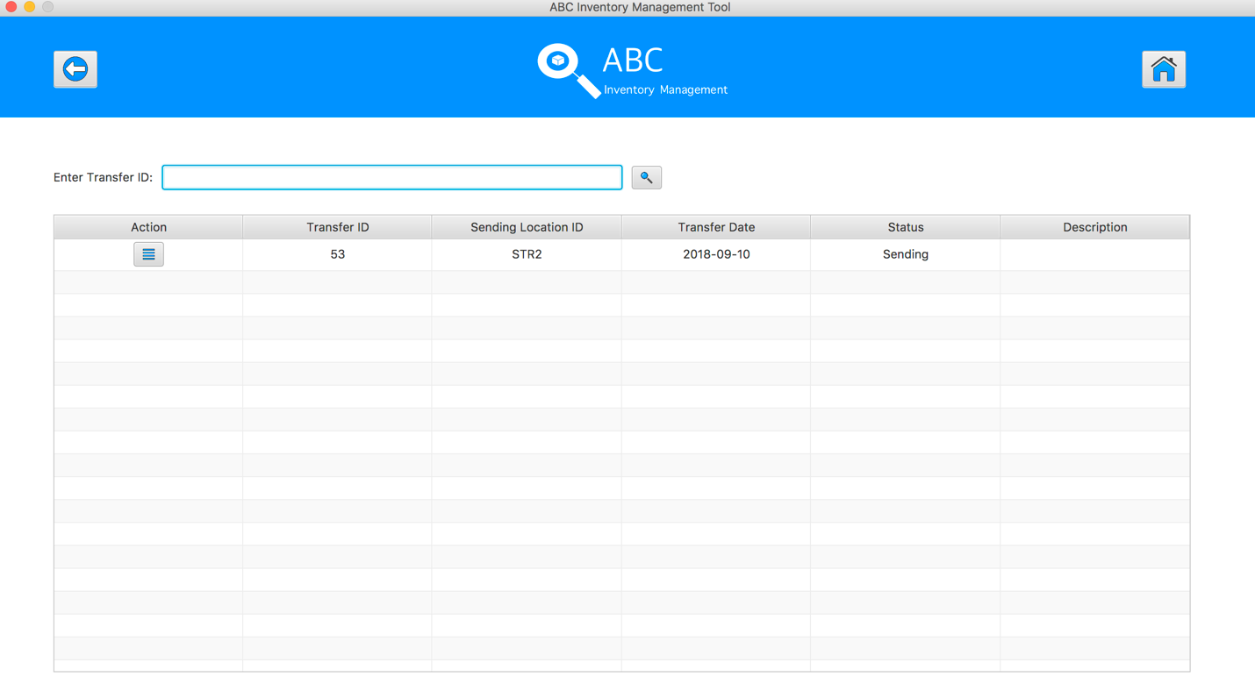

**Step 2**

Click on the “View Product in this Transfer” button of transfer ID = 52, the system displays the sending products detail for accepting 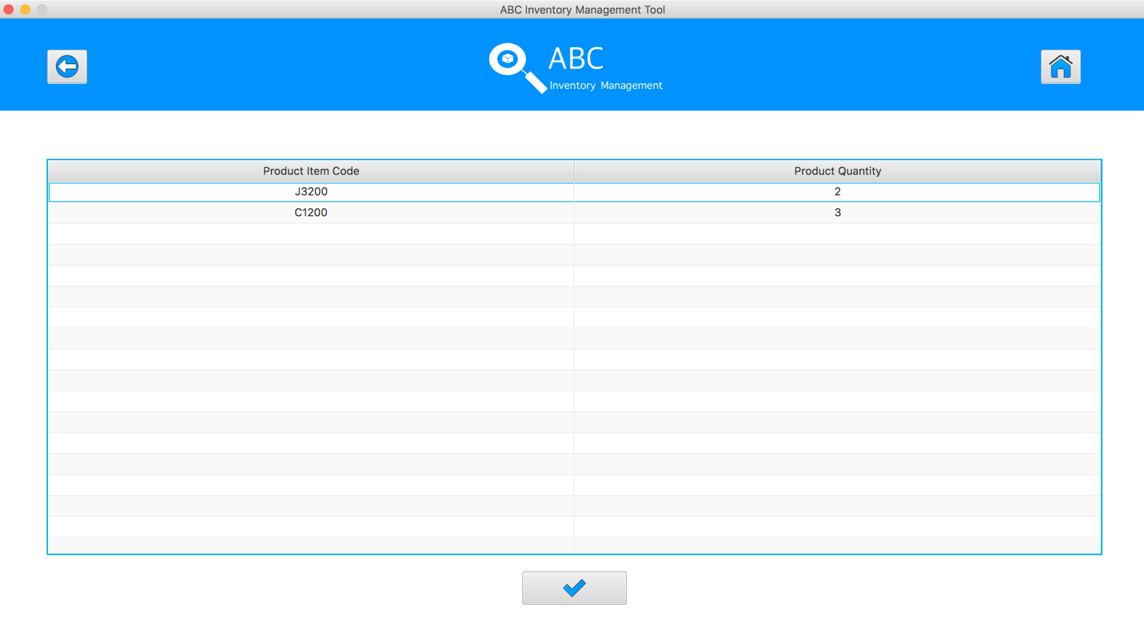

**Step 3**

Click on the “Accept” Button 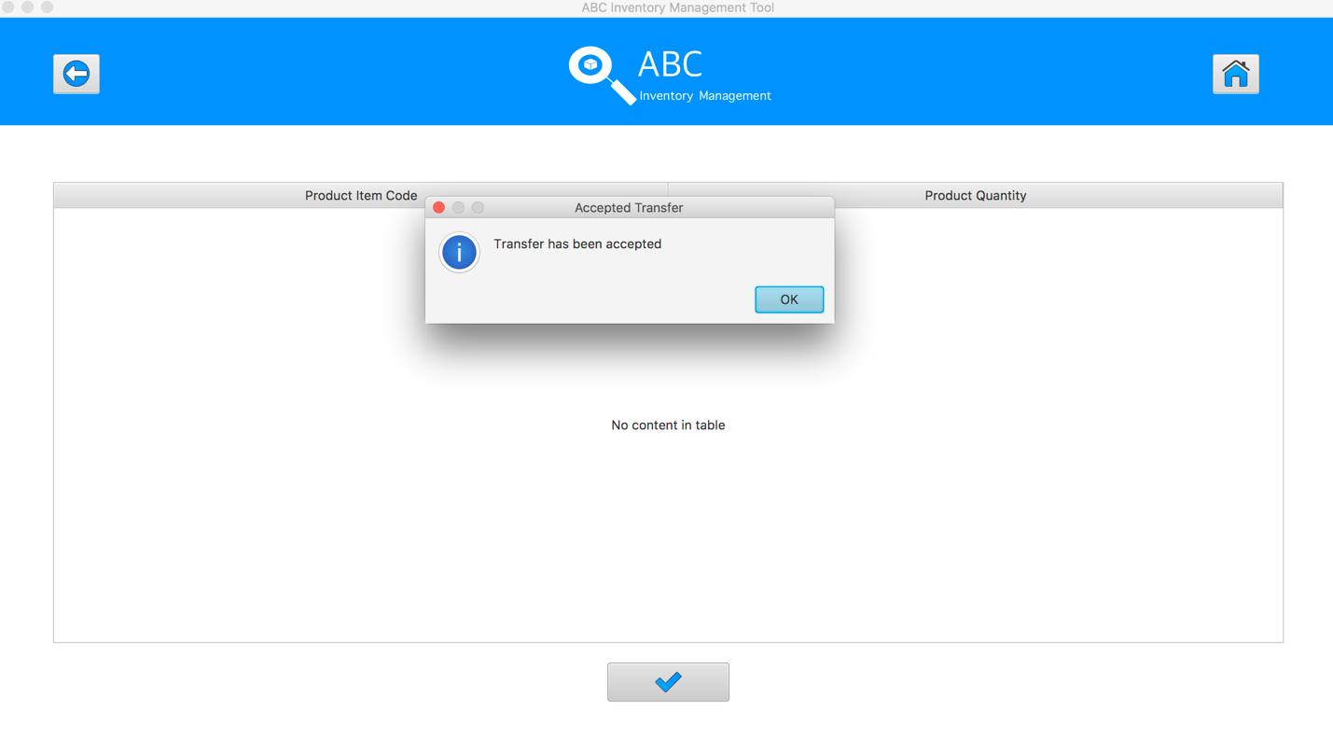

The quantity of accepted product will be changed appropriately.

|  |  |
| --- | --- |
| Before | After |
|  |  |

**APT003- Test Accept The Existed Products In Current Location for Data Set 3:** **PASS**

# APT004- Accept The New Products In Current Location

|  |  |  |  |  |  |
| --- | --- | --- | --- | --- | --- |
| **Test Name** | | Accept The New Products In Current Location (Test Case APT004) | | | |
| **Use Case Tested** | | Accept Product | | | |
| **Test Description** | | This test tests if the system can accept transfer that sending the products what have not been recorded its information in current destination. | | | |
| **Pre-Conditions** | | Product Item Code, Sending Location ID, Destination Location ID, Product Quantity, Description, date, status, transferID | | | |
| **Post-Conditions** | | Accepted Products should be added to the current location, the status of transfer change to “Accepted”, the accepted transfer should be removed from the accept transfer table, the new products information should be added to the current location, the quantity of accepted products should be changed appropriately. | | | |
| **Notes** | | This test assumes that the user knows the transferID. | | | |
| **Result (Pass/Fail/Warning/ Incomplete)** | | Pass | | | |
|  | **Test Step** | | **Expected Test Results** | **P** | **F** |
| 1. | Select Accept Product Button from home page | | Display the Accept Product page |  |  |
| 2. | Input transfer ID in search field and click on the Search Button | | System display correct searched transfer | P |  |
| 3. | Click on the “View Product in this Transfer” button to check the sending products detail for accepting | | System displays a list of sending products and its quantity | P |  |
| 4. | Click on the “Accept” Button | | Accepted Products should be added to the current location, the status of transfer change to “Accepted”, the accepted transfer should be removed from the accept transfer table, the new products information should be added to the current location, the quantity of accepted products should be changed appropriately. | P |  |

## Data Set 1

|  |  |
| --- | --- |
| **Test Data Table** | |
| **transferID** | 53 |
| **Destination** | Warehouse |

#### Result Screenshots

The screenshots of the result on each test step for each data set are given below:

**Step 1**

Open the Accept Product Page

**Step 2**

Click on the “View Product in this Transfer” button of transfer ID = 52, the system displays the sending products detail for accepting 

**Step 3**

Click on the “Accept” Button 

The quantity of accepted product will be changed appropriately.

|  |  |
| --- | --- |
| Before | After |
|  |  |

**APT004- Test Accept The New Products In Current Location** **for Data Set 1:** **PASS**

## Data Set 2

|  |  |
| --- | --- |
| **Test Data Table** | |
| **transferID** | 44 |
| **Destination** | Epping Store |

#### Result Screenshots

The screenshots of the result on each test step for each data set are given below:

**Step 1**

Open the Accept Product Page

**Step 2**

Input transfer ID in search field and click on the Search Button



**Step 3**

Click on the “View Product in this Transfer” button, the system displays the sending products detail for accepting 

**Step 4**

Click on the “Accept” Button 

The quantity of accepted product will be changed appropriately.

|  |  |
| --- | --- |
| Before | After |
|  |  |

**APT004- Test Accept The New Products In Current Location for Data Set 2: PASS**

## Data Set 3

|  |  |
| --- | --- |
| **Test Data Table** | |
| **transferID** | 50 |
| **Destination** | Warehouse |

#### Result Screenshots

The screenshots of the result on each test step for each data set are given below:

**Step 1**

Open the Accept Product Page

**Step 2**

Input transfer ID in search field and click on the Search Button



**Step 3**

Click on the “View Product in this Transfer” button, the system displays the sending products detail for accepting 

**Step 4**

Click on the “Accept” Button 

The quantity of accepted product will be changed appropriately.

|  |  |
| --- | --- |
| Before | After |
|  |  |

**APT004- Test Accept The New Products In Current Location** **for Data Set 3:** **PASS**